Wenjie

IT 520-A – Enterprise Infrastructure & Networks

Questions:

1. Is your browser running HTTP version 1.0 or 1.1?

Answer: My browser is running HTTP version 1.1

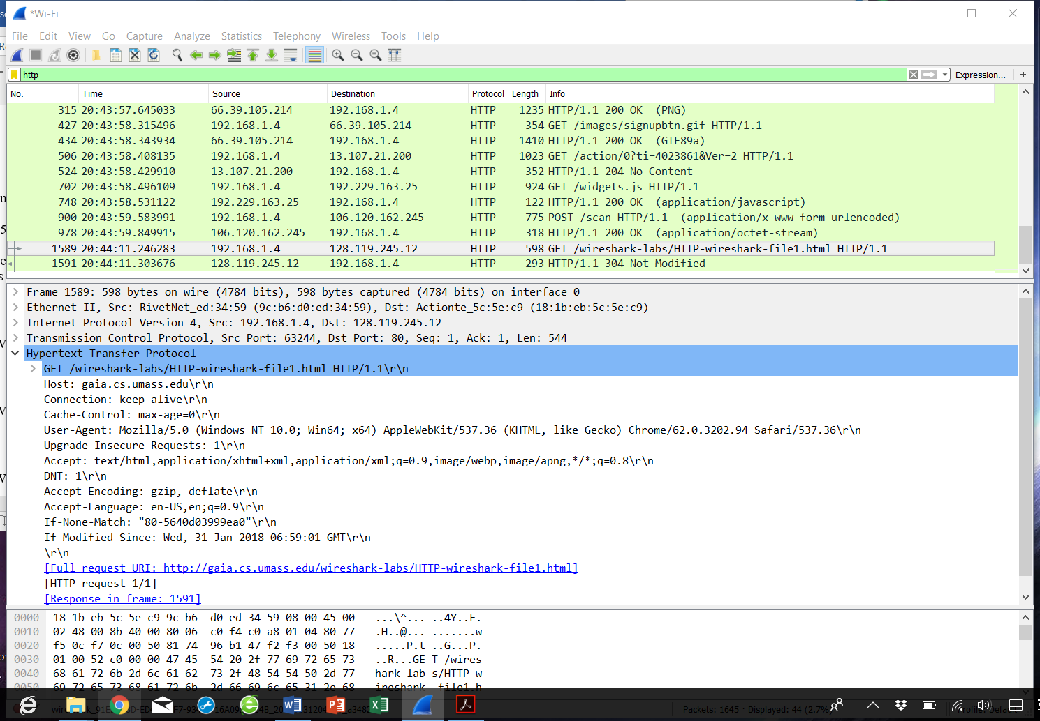

2. When was the HTML file that you are retrieving last modified at the server?

Answer: Last modified: Thu, 01 Feb 2018 06:59:01 GMT

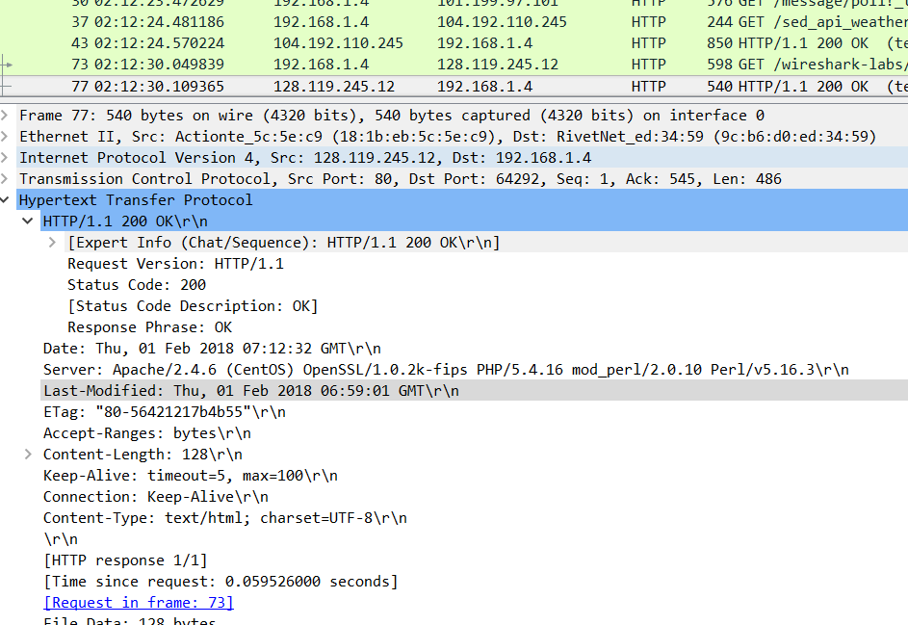

3. What is the IP address of your computer? Of the gaia.cs.umass.edu server?

Answer: IP address of my computer is 192.168.1.4 and that of the gaia server is 128.119.245.12



4. What languages (if any) does your browser indicate that it can accept to the server?

Answer: The languages is en-US (US english), en (other types of English)

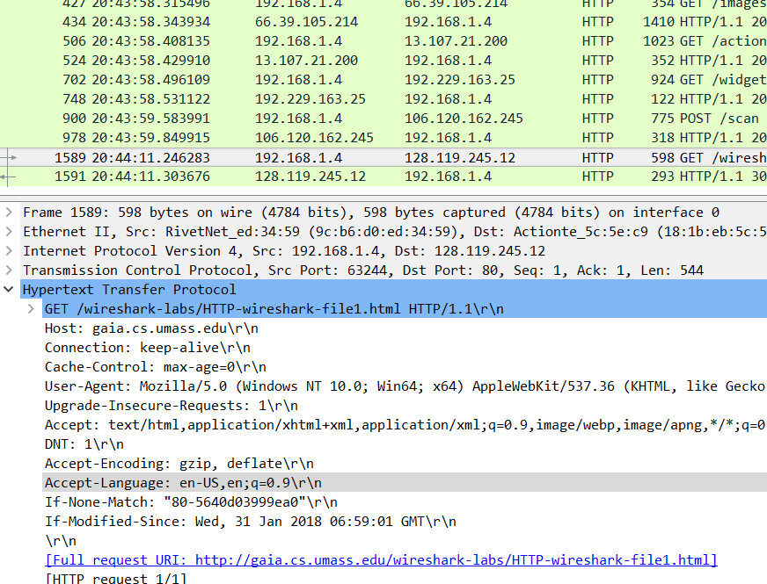

5. When was the HTML file that you are retrieving last modified at the server?

Answer: Last modified: Thu, 01 Feb 2018 06:59:01 GMT

